Chapter test with answers
Chapter 5 Calculating chemical quantities
Time permitted: 30 minutes
 | Section | Number of questions | Marks available
A | Multiple choice | 15 | 15
B | Short answer | 5 | 15
 | Total |  | 30
Scale:
A+ | 29–30 | A | 26–28 | B | 23–25 | C | 19–22 | D | 15–18 | E | 9–14 | UG | 0–8
Section A Multiple choice (15 marks)
Section A consists of 15 questions, each worth one mark. Each question has only one correct answer. Circle the correct answer. Attempt all questions. Marks will not be deducted for incorrect answers. You are advised to spend no more than 15 minutes on this section.
1 Which of the following is closest to the relative molecular mass of carbon dioxide?
A 28 g mol–1
B 44 g mol–1
C 14 g mol–1
D 22 g mol–1
2 The relative mass of silver chloride is more correctly called:
A relative atomic mass.
B relative molecular mass.
C relative formula mass.
D relative compound mass.
3 How many feathers are there in 2 moles of feathers?
A 6.0 × 1023
B 1.2 × 1024
C Need to know average mass of feathers
D 3 × 1023

4 The mass of 1 mole of nitrogen dioxide is closest to:
A 6.02 × 1023.
B 30 g.
C 46 g.
D 44 g.
5 What is required to calculate the percentage composition of a substance?
A Chemical formula and relative atomic masses of the elements in the compound
B Chemical formula only
C Chemical formula and relative mass of the compound
D Relative mass of the compound only
6 The Avogadro constant is equal to:
A 6.02 × 1023 atoms.
B 6.02 × 1023 g.
C 12.01 atoms.
D 12.01 g.
7 Which of the following describes the mass of Avogadro’s number of particles?
A 35 g of methane
B 40 g of lithium fluoride
C 16 g of oxygen gas
D 36.5 g of hydrogen chloride
8 How many moles of water are produced when 0.03 moles of aluminium hydroxide decomposes according to the following equation?
2Al(OH)3(s) 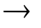 Al2O3(s) + 3H2O(l)
A 0.045 mol
B 0.03 mol
C 0.06 mol
D 0.015 mol
9 Which of the following is both an empirical and molecular formula?
A H2O2
B C6H12O6
C C2H4
D C12H22O11
10 The total number of particles in 4.5 g of KCl is:
A 6.02 × 1023 particles.
B 3.6 × 1022 particles.
C 0.06 particles.
D 2.7 × 1024 particles.

11 How many moles of aluminium are in 0.15 mol Al2(SO4)3?
A 0.3 mol
B 0.15 mol
C 0.45 mol
D 1.0 mol
12 Which of the following does not have a molecular formula?
A Carbon tetrachloride
B Nitrogen dioxide
C Calcium carbonate
D Phosphorus trichloride
13 The coefficients of a chemical equation can represent:
A mole ratios.
B particle ratios.
C mass ratios.
D both mole ratios and particle ratios.
14 The ratio of Mg:P:O atoms in Mg3(PO4)2 is:
A 1:2:2.
B 1:3:3.
C 3:1:4.
D 3:2:8.
15 1 mole of chlorine gas and 1 mole of lithium chloride are weighed. The total mass is:
A 78 g.
B 113.5 g.
C 2 moles.
D 1.2 × 1024 particles.

Section B Short answer (15 marks)
Section B consists of five questions. Write your answers in the spaces provided. You are advised to spend 20 minutes on this section.
1 Determine the percentage composition of iron(II) sulfate. (3 marks)
Answer: FeSO4
Mass of Fe = 55.85
Mass of S = 32.07
Mass of O = 16.00 × 4
Formula mass = 55.85 + 32.07 + (16.00 × 4) = 151.92
%Fe = 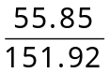 × 100 = 36.8%
%S = 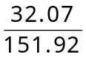 × 100 = 21.1%
%O = 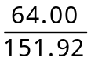 × 100 = 42.1%
2 Respiration can be represented by the following equation:
C6H12O6 + 6O2 6CO2 + 6H2O + energy
a Calculate the molecular mass of glucose. (1 mark)
Answer: C6H12O6
= (6 × 12.01) + 12(1.008) + 6(16.00)
= 180.16
b How many moles of carbon dioxide are produced per mole of glucose?
(1 mark)
Answer: 6
c How many particles of water are produced per mole of oxygen? (1 mark)
Answer: 1 mole of water per 1 mole of oxygen. This means there are 6.02 × 1023 molecules of water produced per mole of oxygen.
3 Hydrogen sulfide gas reacts with oxygen gas to form sulfur dioxide gas and water according to the equation:
________H2S + ________ O2 ________SO2 + ________ H2O
a Balance the equation by writing the correct coefficients in the spaces above. (1 mark)
Answer: 2H2S + 3O2 2SO2 + 2H2O

b Calculate the mass of sulfur dioxide produced from 1.0 kg of hydrogen sulfide. (2 marks)
Answer: 1 kg = 1000 g of H2S
n = 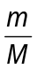
nH2S = nSO2 = 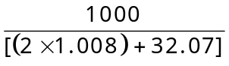
n = 29.337…
mSO2 = n × M
= 29.337… × 64.07
= 1879.62…
= 1.88 kg SO2
4 An unknown substance has the following percentage composition by mass:
49.5% C, 5.2% H, 16.6% O, 28.8% N.
a Determine the empirical formula of this compound. (2 marks)
Answer: Mass (in 100 g): C = 49.5 g, H = 5.2 g, O = 16.6 g, N = 28.8 g
nC = 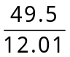 = 4.12
nH = 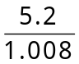 = 5.1587
nO = 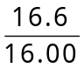 = 1.0375
nN = 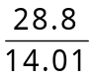 = 2.0557
C = 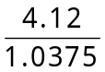 = 3.97 = 4
H = 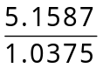 = 4.97 = 5
O = 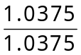 = 1
N = 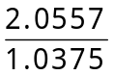 = 1.98 = 2
C4H5ON2
b If the molar mass of the compound is 194.19 gmol–1, determine the molecular formula. (1 mark)
Answer: (4 × 12) + (5 × 1) + (2 × 14) + (1 × 16.00) = 97
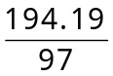 = 2
C8H10O2N4
5 A piece of zinc metal of mass 0.73 g is added to 1.3 g of hydrochloric acid. The following reaction takes place.
Zn(s) + 2HCl(aq) → ZnCl2(aq) + H2(g)
a Calculate the moles of each reactant present before the reaction takes place. (1 mark)
Answer: nZn = 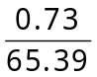
= 0.1116… mol
nHCl = 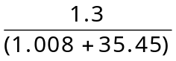
= 0.035 66… mol
b One reactant is in excess (there is too much of it). Identify which reactant is in excess and by how many moles. (1 mark)
Answer: Zn:HCl = 1:2 Only need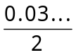 mol of Zn. Zn is in excess by
0.1116 – 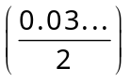 = 0.094 mol
c Calculate the mass of hydrogen gas produced in this reaction. (1 mark)
Answer:
mH2 = n × M
= 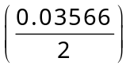 × (2 × 1.008)
= 0.0359…
= 0.036 g H2 gas
End of test (30 marks)

